2. G. ADDITION POLYMERISATION
Addition polymerisation is another process (along with condensation polymerisation) that produces long-chain polymers.
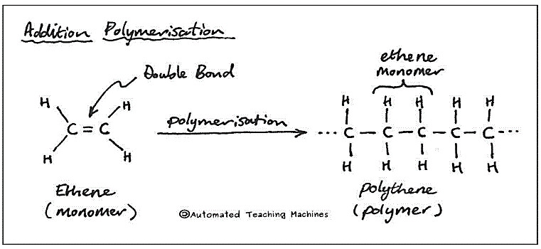
In addition polymerisation, the monomers are small unsaturated molecules. The monomers contain a carbon-carbon double bond that is broken during the polymerisation process. The two carbon atoms either side of the double bond can now from new bonds with the carbon atoms in other monomers. An example on the right shows the addition polymerisation of ethene (the simplest unsaturated monomer possible) to make polyethene.
Two notes:
- The polymerisation process is not a simple one step process, but can be represented as such – like in the diagram.
- Polyethene is the IUPAC name for this polymer, but is commonly often referred to as polythene, or polyethylene.

Some examples of these reactions are shown in Figure 4.2.4.
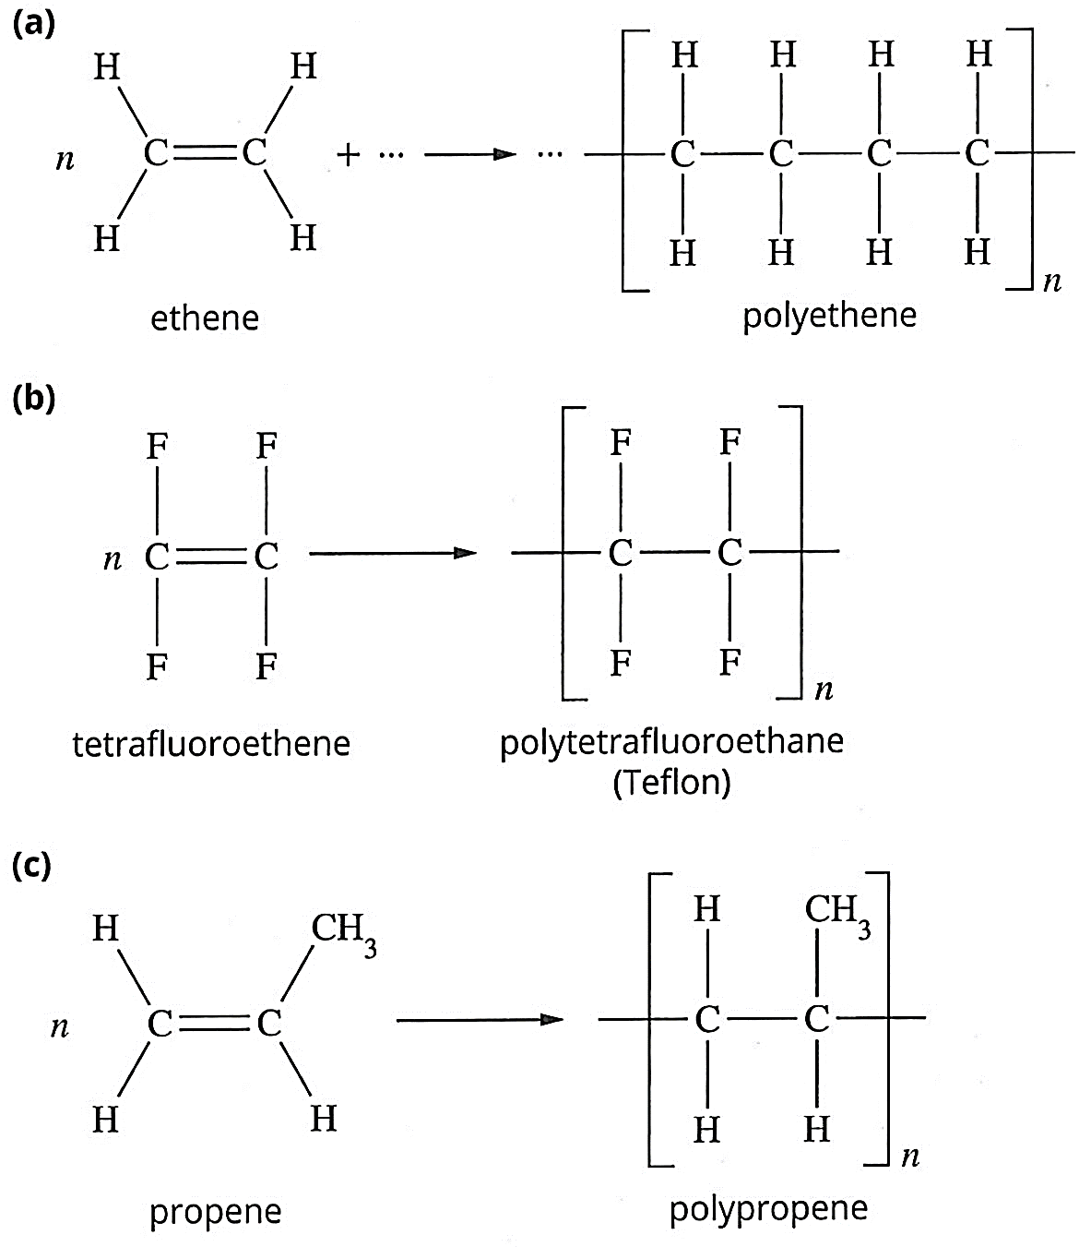
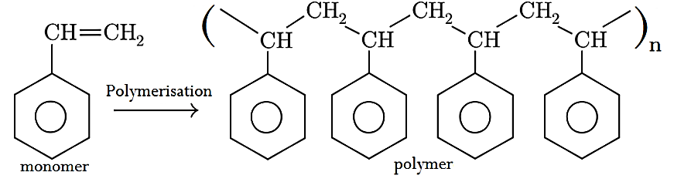
FIGURE 4.2.4
(d)
a) Formation of PE from ethene (two forms, HOPE and LOPE, are produced by varying the reaction conditions),

b) Formation of polytetrafluoroethene (Teflon) from tetrafluoroethene, and

c ) Formation of polypropene from propene

d) Formation of polystyrene from styrene (phenylethene(systematic name), or ethenylbenzene(preferred name))

Factors affecting polymer properties
The properties of addition polymers vary widely. They differ in their strength and densities, and range from being biodegradable to almost imperishable.
Several factors determine the properties of polymers. These include:
- The length of the chain. The longer the chain, the greater the dispersion forces and the higher the melting point
- Functional groups in the R chain. These affect the intermolecular bonding between polymer chains. The stronger these forces, the higher the melting point and the more rigid the polymer
- The degree of branching that occurs as the polymer forms. The degree of branching can affect the way the polymer chain align, or pack together.
- The alignment of the polymer chains that produce different regions in the polymer. When chains can be lined up in an orderly fashion, they can pack closer together and bond more strongly. These ordered (crystalline) regions are stronger and more rigid, whereas disordered (amorphous) sections are weaker. Polyethene, polypropylene and polytetrafluoroethene provide examples of the effect of structure on the properties of polymers.

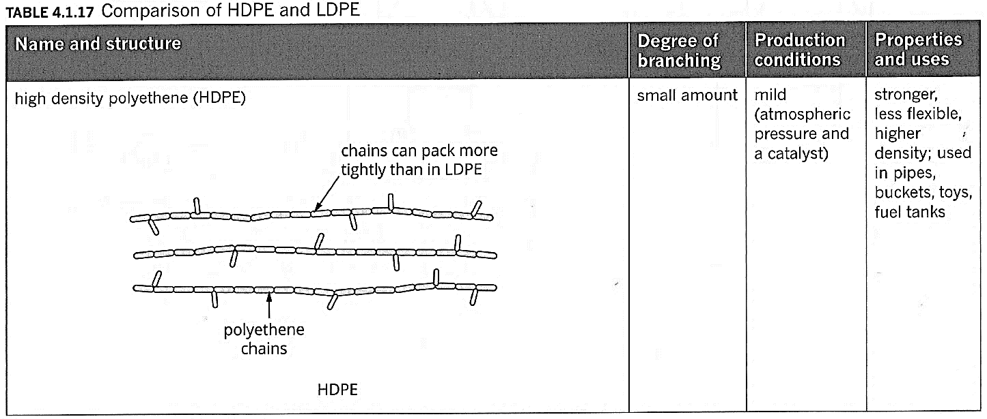
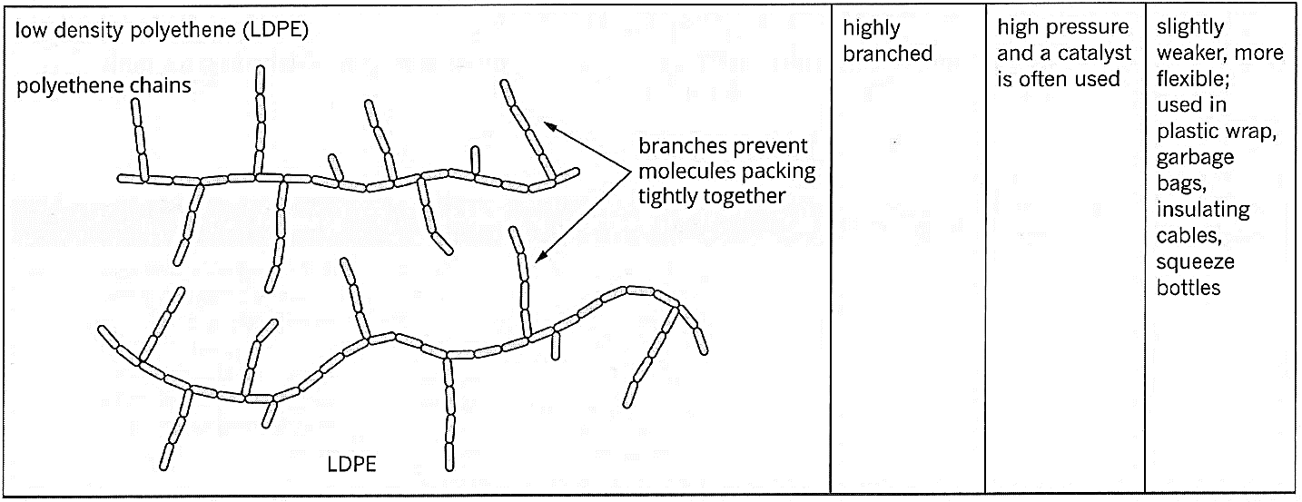
Polyethene
Polyethene is manufactured in high-density and low-density forms, called HDPE and LDPE.
Table 4.1.17 summarises the differences between HDPE and LDPE.
HDPE has long polymer chains with very few short branches, allowing the chains to pack closely and form a rigid, highly crystalline material.
By contrast, LDPE is highly branched in a manner that prevents crystalline regions forming. It therefore has an amorphous structure and is softer and more flexible.

Polypropene
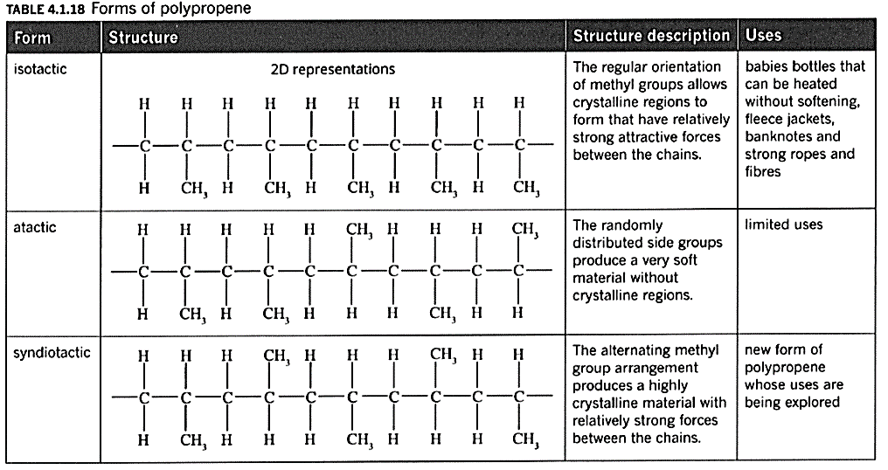
Polypropene is similar to polyethene but with the additional methyl group acting as a very short branch of the polymer chain. The arrangement of the methyl group can cause differences in the physical properties of the polymer. The properties and the uses of the polymer depend on the alignment of the methyl groups along the polymer chain (Table 4.1.18).
These three basic structures (isotactic, atactic, syndiotactic) are common in all addition polymers with an R sidegroup like polypropene. PVC - polyvinyl chloride, or polychloroethene is one example. Polystyrene, made from phenylethene (styrene) is another.

Polytetrafluoroethene
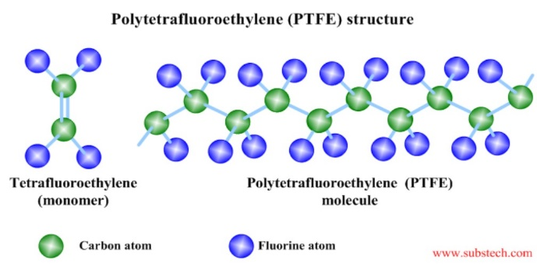
Polytetrafluoroethene, which is commonly known by the brand name Teflon, has a similar structure to polyethene, but with all the hydrogen atoms replaced by fluorine atoms. Because fluorine is a small, highly electronegative element, the carbon fluoride bond is particularly strong, and the strength of intermolecular forces is much weaker than other molecules. This means the molecules has very unusual and very distinctive properties.
Polytetrafluoroethene is very unreactive and has exceptional non-stick properties. It is used as a non-stick surface in saucepans, medical implants and GORE-TEXclothing.

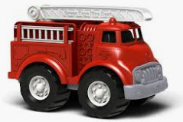
QUESTIONS
1. Explain how the polymer polyethene can be used to make rigid plastic toys like the truck pictured, and soft plastic wraps commonly known as cling film given that both these applications appear to require very different physical properties.
2. Explain how the position of the methyl group in polypropene influences the physical properties of the polymer.
3. List the unique physical properties of polytetrafluoroethene, and explain how these are caused by the structure of the polymer molecule.
4. (a) Draw the chemical equation for the production of an addition polymer from 2-Butene. In your answer include the structural formulas of the monomer and the polymer.
(b) Draw the chemical equation for the production of an addition polymer from 1,2-dichloroethene. In your answer include the structural formulas of the monomer and the polymer.
(c) What differences would there be in the physical properties of the polymers created in (a) and (b). Explain these differences using your understanding of the structures of the polymers.
5. RESEARCH – what are the general condition for each of the addition polymerisation reactions (polyethene – LDPE and HDPE, polypropene, and polytetrafluorethene) in terms of temperature, pressure, and the presence of a catalyst/initiator?

